OUTPUT:
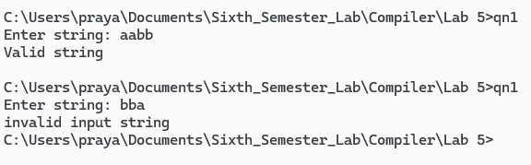

OUTPUT:
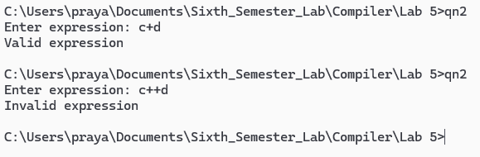

OUTPUT:
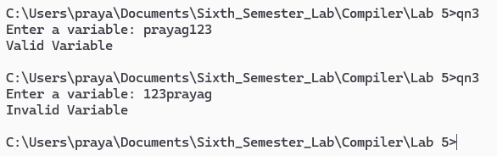

OUTPUT:
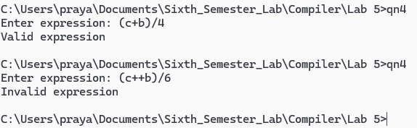
OUTPUT:
